Project -3

Responsive Website

Notes

* We can not use width:1024px bcz its fixed it can not be responsive.
* <!-- .col>h1{box} -->
* <!-- .col>h1{box}\*10 -->
* <!-- (.col>h1{box})\*10 -->
* First select code than - > Alt + shift + down Arrow for copy same line
* Multi cursor -> ctrl + alt + down key

Index.html

<!DOCTYPE html>

<html lang="en">

<head>

    <meta charset="UTF-8">

    <meta http-equiv="X-UA-Compatible" content="IE=edge">

    <meta name="viewport" content="width=device-width, initial-scale=1.0">

    <title>Responsive website.</title>

    <link rel="stylesheet" href="style.css">

</head>

<body>

    <h1>Vishal Datodiya</h1>

</body>

</html>

Style.css

h1{

    color: blue;

    font-size: 20px;

}

/\* Tablet view (if you decrease the size of chrome than it will change

the color of h1 content \*/

@media (max-width:768px){

    h1{

        color: chartreuse;

        /\* font size says that : i am specific so i will change my size \*/

         font-size: 40px;

    }

}

/\* Mobile view \*/

@media (max-width: 500px){

    h1{

        color: darkmagenta;

        font-size: 60px;

    }

}

First Part

Minimize the screen size and try

* desktop view
* Tablet view
* Mobile view

There is a hide classes for the different view in desktop mobile and tablet just check it out for better responsive website.

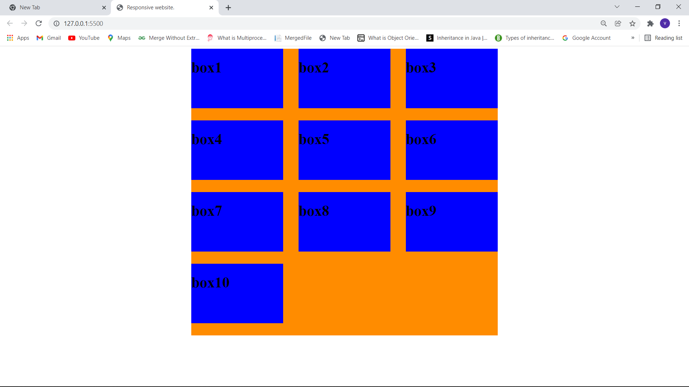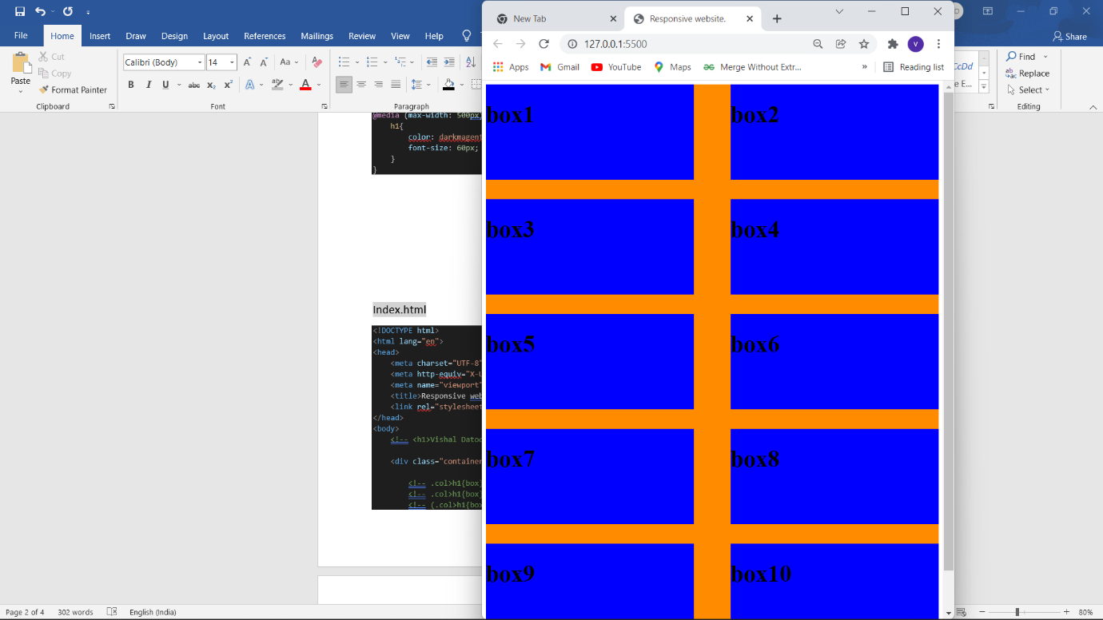

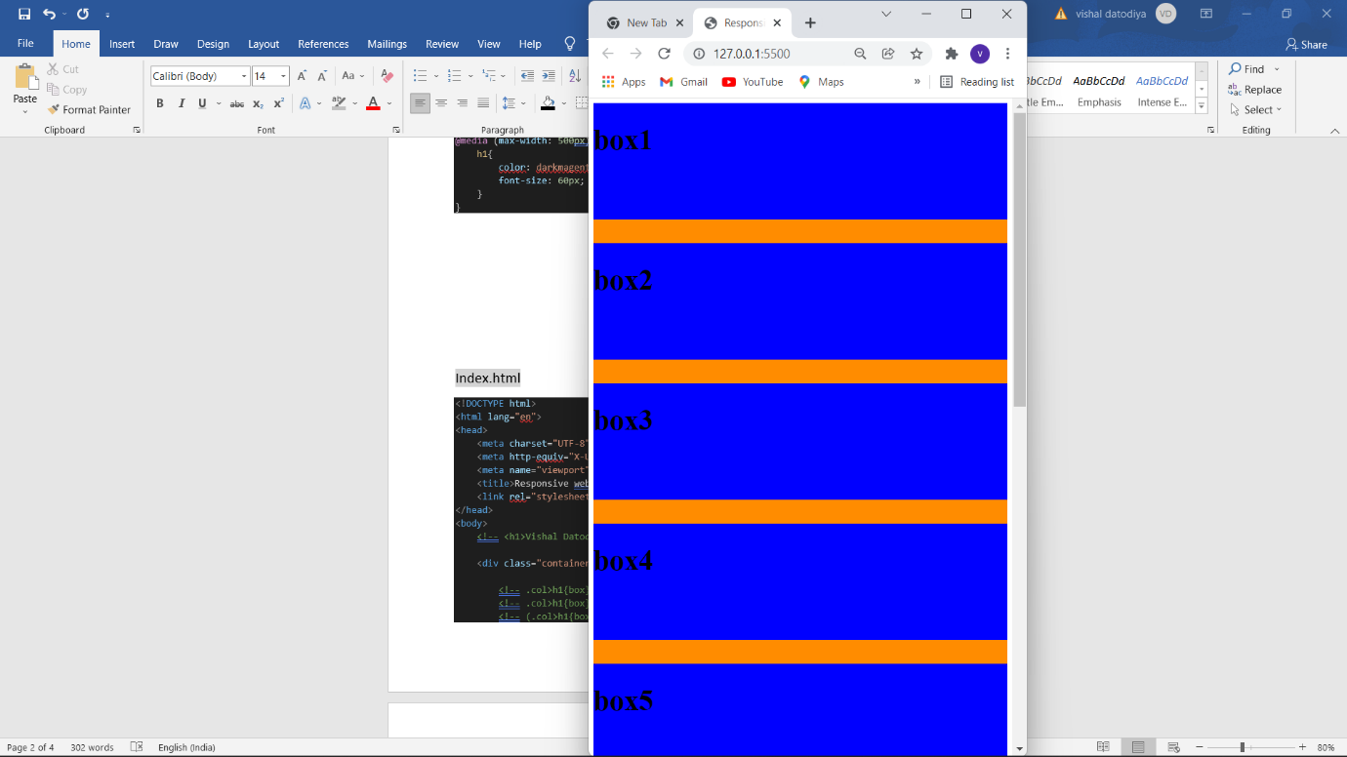

Index.html

<!DOCTYPE html>

<html lang="en">

<head>

    <meta charset="UTF-8">

    <meta http-equiv="X-UA-Compatible" content="IE=edge">

    <meta name="viewport" content="width=device-width, initial-scale=1.0">

    <title>Responsive website.</title>

    <link rel="stylesheet" href="style.css">

</head>

<body>

    <!-- <h1>Vishal Datodiya</h1> -->

    <div class="container">

        <!-- .col>h1{box} -->

        <!-- .col>h1{box}\*10 -->

        <!-- (.col>h1{box})\*10 -->

        <div class="col"><h1>box1</h1></div>

        <div class="col"><h1>box2</h1></div>

        <div class="col"><h1>box3</h1></div>

        <div class="col"><h1>box4</h1></div>

        <div class="col hide-mobile"><h1>box5</h1></div>

        <div class="col hide-mobile"><h1>box6</h1></div>

        <div class="col hide-mobile"><h1>box7</h1></div>

        <div class="col hide-mobile"><h1>box8</h1></div>

        <div class="col hide-mobile"><h1>box9</h1></div>

        <div class="col hide-mobile-only hide-desktop-only"><h1>box10</h1></div>

    </div>

</body>

</html>

Style.css

.container{

    background-color: darkorange;

    min-height: 500px;

    /\* width: 1024px;  we can not use this bcz it is a fix it can not be responsive \*/

    max-width: 1024px;

    margin: auto;

    display: flex;

    flex-wrap: wrap;

    justify-content: space-between;

}

h1{

    font-size: 50px;

}

.col{

    background-color: blue;

    min-height: 200px;

    width: 30%;

    /\* display: inline-block; \*/

    margin-bottom: 40px;

}

.hide-desktop-only{

    display: none;

}

@media (max-width: 1000px){

    .col{

        width: 46%;

    }

    .hide-desktop-only{

        display: block;

    }

}

@media (max-width: 800px){

    .col{

        width: 100%;

    }

    .hide-mobile{

        display: none;

    }

}

Part 2

Images in boxes

Index.html

<!DOCTYPE html>

<html lang="en">

<head>

    <meta charset="UTF-8">

    <meta http-equiv="X-UA-Compatible" content="IE=edge">

    <meta name="viewport" content="width=device-width, initial-scale=1.0">

    <title>Responsive website.</title>

    <link rel="stylesheet" href="style.css">

</head>

<body>

    <!-- <h1>Vishal Datodiya</h1> -->

    <div class="header-container">

        <header>

            <div class="logo"><strong>Vishal Datodiya :</strong> Full Stack Developer</div>

            <nav>

                <a href="#" class="mybutton">HOME</a>

                <a href="#" class="mybutton">HOME</a>

                <a href="#" class="mybutton">HOME</a>

            </nav>

        </header>

    </div>

    <div class="container">

        <!-- .col>h1{box} -->

        <!-- .col>h1{box}\*10 -->

        <!-- (.col>h1{box})\*10 -->

        <div class="col"><img src="image1@2x.png" alt="">

            <p>Vishal : Lorem ipsum, dolor sit amet consectetur adipisicing elit.</p>

        </div>

        <div class="col"><img src="image2@2x.png" alt="">

            <p>Vishal : Lorem ipsum, dolor sit amet consectetur adipisicing elit.</p>

        </div>

        <div class="col"><img src="image3@2x.png" alt="">

            <p>Vishal : Lorem ipsum, dolor sit amet consectetur adipisicing elit.</p>

        </div>

        <div class="col"><img src="image4@2x.png" alt="">

            <p>Vishal : Lorem ipsum, dolor sit amet consectetur adipisicing elit.</p>

        </div>

        <div class="col hide-mobile"><img src="image5@2x.png" alt="">

            <p>Vishal : Lorem ipsum, dolor sit amet consectetur adipisicing elit.</p>

        </div>

        <div class="col hide-mobile"><img src="image6@2x.png" alt="">

            <p>Vishal : Lorem ipsum, dolor sit amet consectetur adipisicing elit.</p>

        </div>

        <div class="col hide-mobile"><img src="image7@2x.png" alt="">

            <p>Vishal : Lorem ipsum, dolor sit amet consectetur adipisicing elit.</p>

        </div>

        <div class="col hide-mobile"><img src="image8@2x.png" alt="">

            <p>Vishal : Lorem ipsum, dolor sit amet consectetur adipisicing elit.</p>

        </div>

        <div class="col hide-mobile"><img src="image9@2x.png" alt="">

            <p>Vishal : Lorem ipsum, dolor sit amet consectetur adipisicing elit.</p>

        </div>

        <div class="col hide-mobile-only hide-desktop-only"><img src="image10@2x.png" alt="">

            <p>Vishal : Lorem ipsum, dolor sit amet consectetur adipisicing elit.</p>

        </div>

    </div>

</body>

</html>

Style.css

/\* desktop view \*/

/\* h1{

    color: blue;

    font-size: 20px;

} \*/

/\* Tablet view (if you decrease the size of chrome than it will change

the color of h1 content \*/

/\*

@media (max-width:768px){

    h1{

        color: chartreuse;

        /\* font size says that : i am specific so i will change my size \*/

        /\* font-size: 40px;

    }

} \*/

/\* Mobile view \*/

/\* @media (max-width: 500px){

    h1{

        color: darkmagenta;

        font-size: 60px;

    }

} \*/

body{

    font-family: 'Source Sans 3', sans-serif;

    background-color: thistle;

    margin-top: 0px;

}

.header-container{

    background-color: rgb(66, 65, 65);

    min-height: 100px;

    margin-bottom: 40px;

    color: white;

    position: fixed;

    width: 100%;

}

header{

    max-width: 1024px;

    min-height: 100px;

    /\* background-color: rgb(255, 0, 191); \*/

    margin: auto;

    display: flex;

    justify-content: space-between;

    align-items: center;

    font-size: 25px;

}

.logo{

    margin: 0px 0px 0px 10px;

}

.mybutton{

    color: white;

    text-decoration: none;

    border: 1px solid white;

    padding: 10px;

    margin: 0px 10px;

    font-size: 20px;

}

.container{

    min-height: 500px;

    /\* width: 1024px;  we can not use this bcz it is a fix it can not be responsive \*/

    max-width: 1024px;

    margin: auto;

    display: flex;

    flex-wrap: wrap;

    justify-content: space-between;

    padding-top: 150px;

}

h1{

    font-size: 50px;

}

.col{

    /\* background-color: blue;

    min-height: 200px; \*/

    width: 30%;

    /\* display: inline-block; \*/

    margin-bottom: 40px;

    background-color:lightgreen;

}

.hide-desktop-only{

    display: none;

}

.col img{

 width: 100%;

 height: auto;

}

p{

    font-size: 20x;

    padding: 20px 30px;

    line-height: 1.5;

}

.col p::first-line{

    font-weight: bold;

}

/\* tablet view \*/

@media (max-width: 1000px){

    .col{

        width: 46%;

    }

    .hide-desktop-only{

        display: block;

    }

}

/\* Mobile view \*/

@media (max-width: 800px){

    .col{

        width: 100%;

    }

    .hide-mobile{

        display: none;

    }

    header{

        display: block;

        text-align: center;

    }

    nav a{

        display: block;

    }

    .logo{

        padding: 40px 0px;

    }

    .mybutton{

        margin: 0;

    }

    /\*we use this above redefine classes so when we show in mobile then it will cover some part of our first picture \*/

    .header-container{

        position: relative;

    }

    /\* when we used relative position so it gives more space bcz we used more padding in main container \*/

    .container{

        padding: 0;

    }

}